

Welcome Screen Cinq

User guide

Author: Paulo Lima

Version 1.0

September 12, 2019

Histórico de revisão

|  |  |  |  |
| --- | --- | --- | --- |
| Date | Version | Description | Author |
| 12/Sep/2019 | 1.0 | Initial version. | Paulo Lima |

Table of content

1. Adding a visitor page 04
2. Editing a visitor page 12
3. Deleting a visitor page 16
4. Adding a video 18
5. Editing a video 25
6. Deleting a video 28
7. Welcome Screens List 30
8. Deleting/Disabling many W.S. 31
9. Welcome Screen Preview 34

10. Home 35

11. My account 36

12. Deleting my account 38

13. Enrolling a new user 40

1. Adding a visitor page
   1. To add a new visitor page, you can start by clicking directly on *“Add new visitor page”*  on the Welcome Screens List

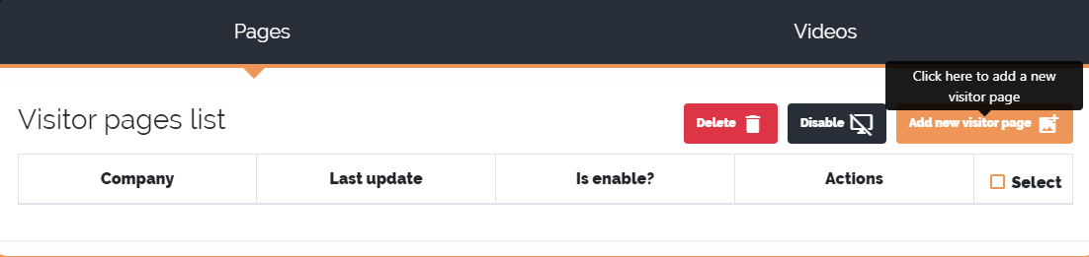

or by clicking on *“Screens”* and then *“New visitor page”* in the navigation bar.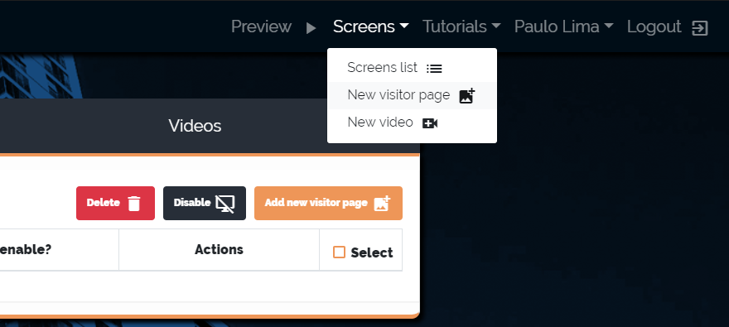

* 1. After that, the screen to add a new visitor page will appear.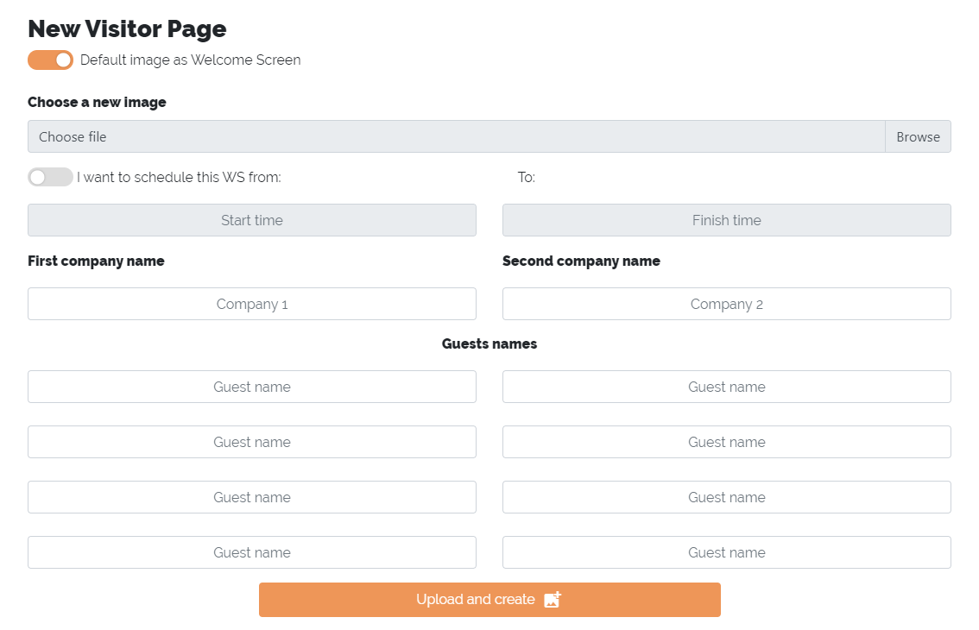
  2. Note that the *“Default Image as Welcome Screen”*  option is selected. This will make Cinq's default photo be used as a background for your visitor page. However, if you want to use a different photo, uncheck this option and you can upload a new photo under *“Choose a new image”*.

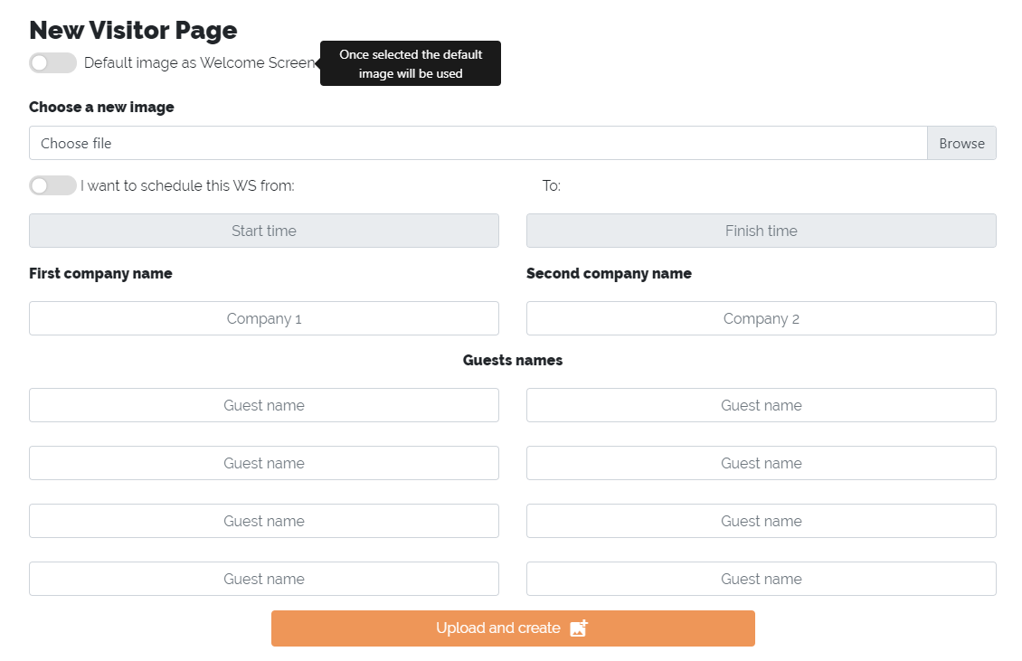

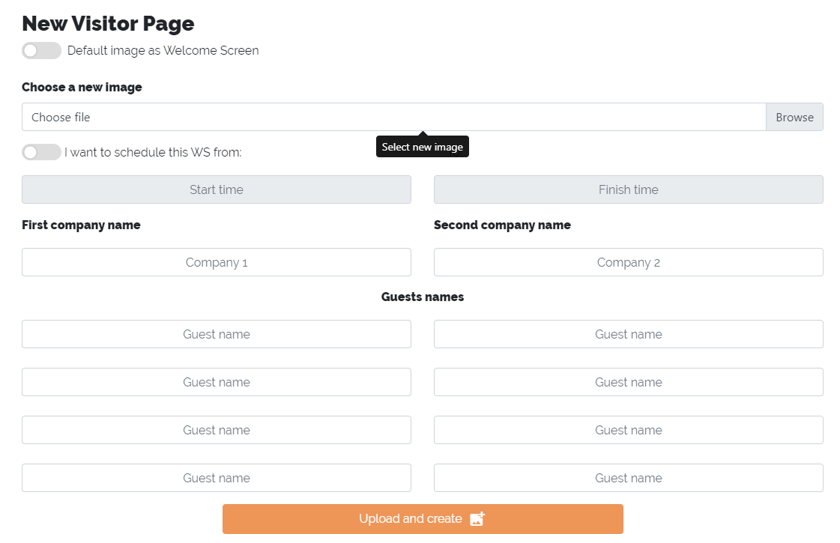

* 1. You may notice from the previous prints that the *“I want to schedule this WS from: ... to:”*  option is not selected. This means that your new visitor page is not scheduled for any date, which will make it to be activate as soon as you complete the process. However, if you want this page to be enabled at a specific date and time, uncheck this option. With that, the fields *"Start time"* and *"Finish time"* will be released and you can choose the dates of activation and deactivation of the screen.

**ATTENTION:**

**- The minimum time to activate a visitor page is one hour ahead.**

**- The start date and time of a page must always be greater than the end date, otherwise the fields will turn red and you will not be able to complete the registration.**

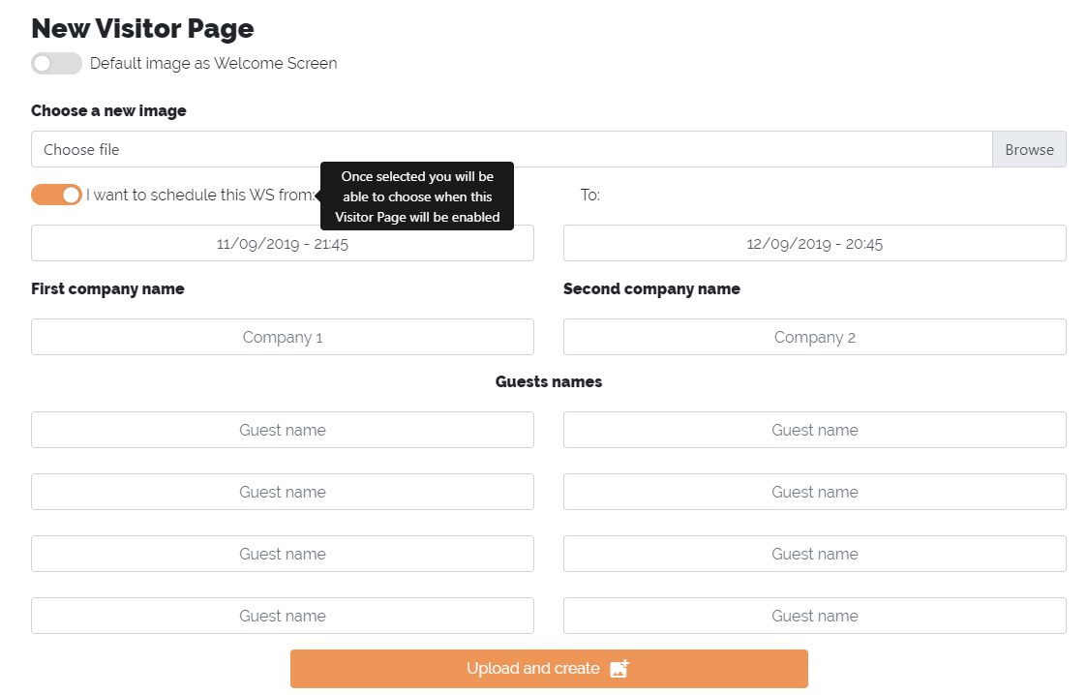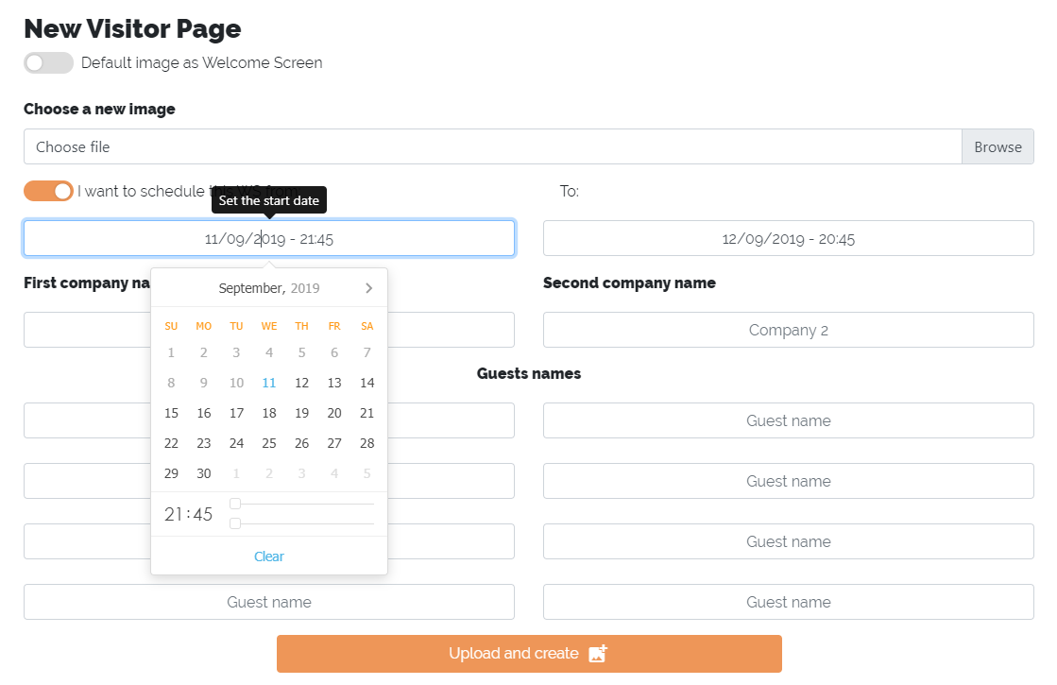

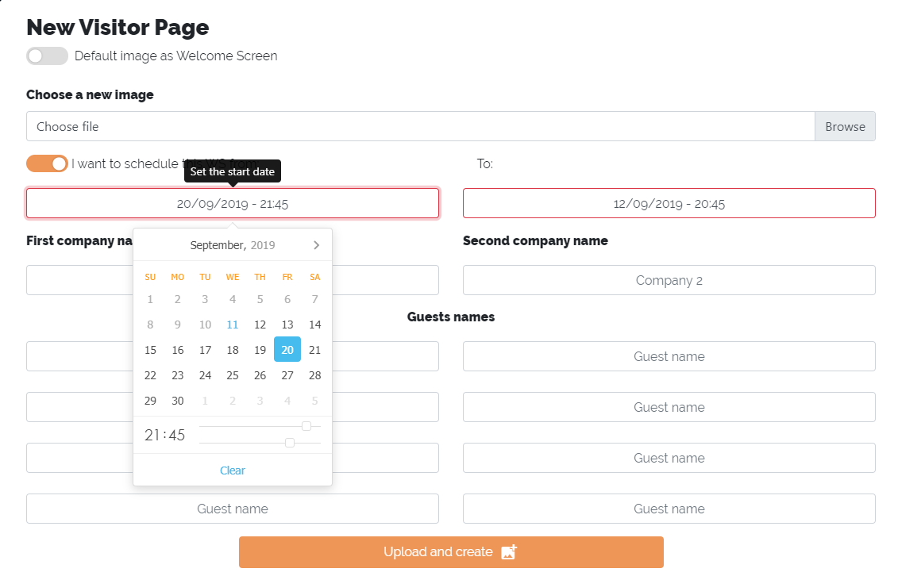

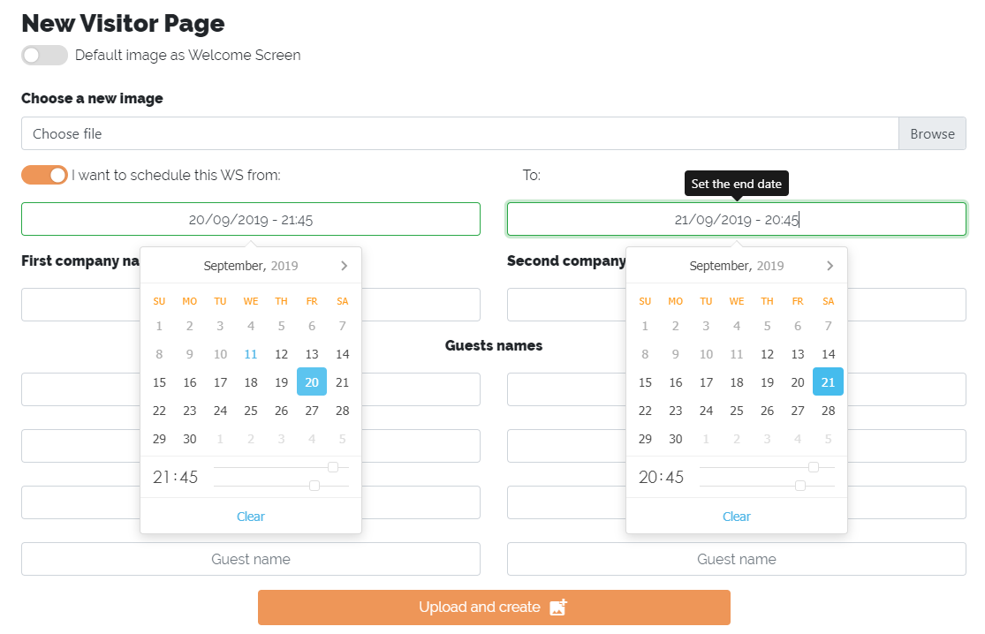

* 1. Fill in the *"First company name"* field. This field is required. You can enter up to two company names per screen. These names will be aligned with the *“Guest name”* which are respectively below them.

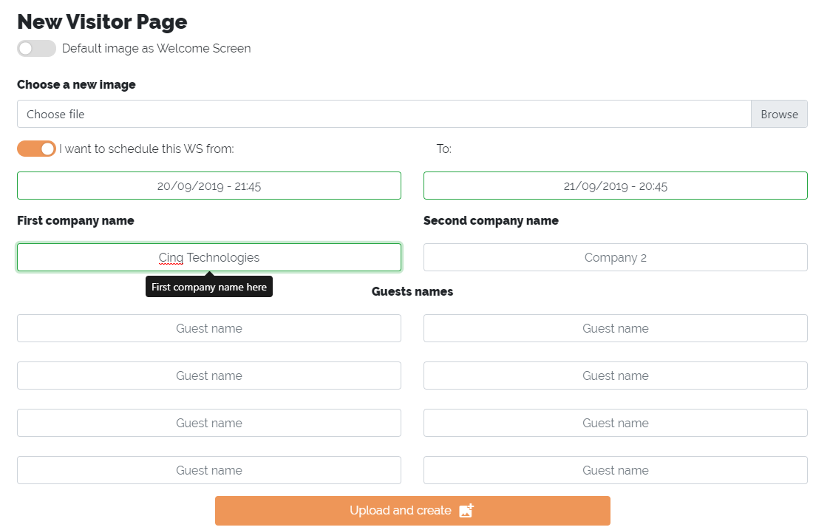

* 1. After that, if necessary, fill in the fields *“Guest name”*. These fields are not required and you can place up to eight of them per screen.

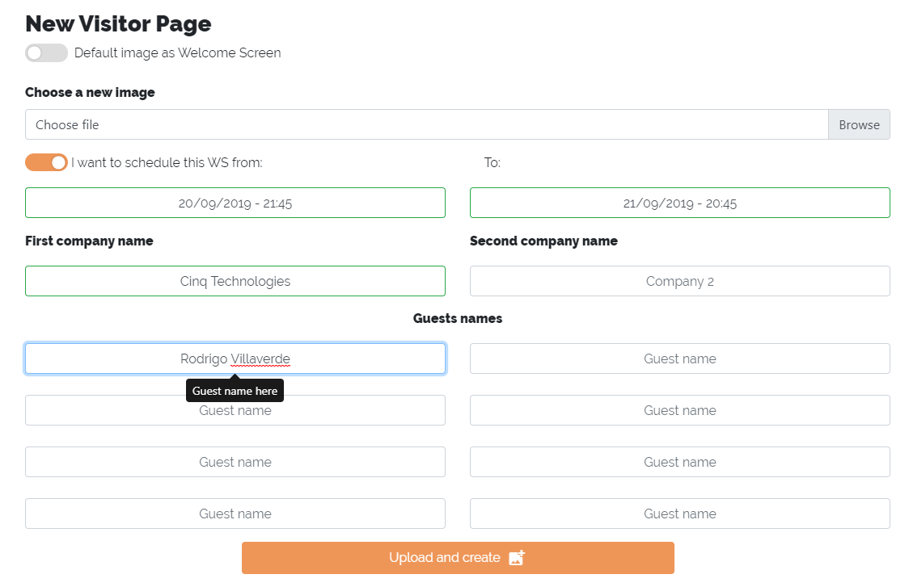

* 1. Now click on *“Upload and create”*. Remember to check if all required fields are filled, otherwise the moment you click the button an error message will appear and you will not be able to proceed. The field that is not right will be marked with red borders. If no problem occurs, a success message will appear with the button *“OK, keep going!”* . After clicking it you will be redirected to the Welcome Screen List and your screen will already be registered on the list.

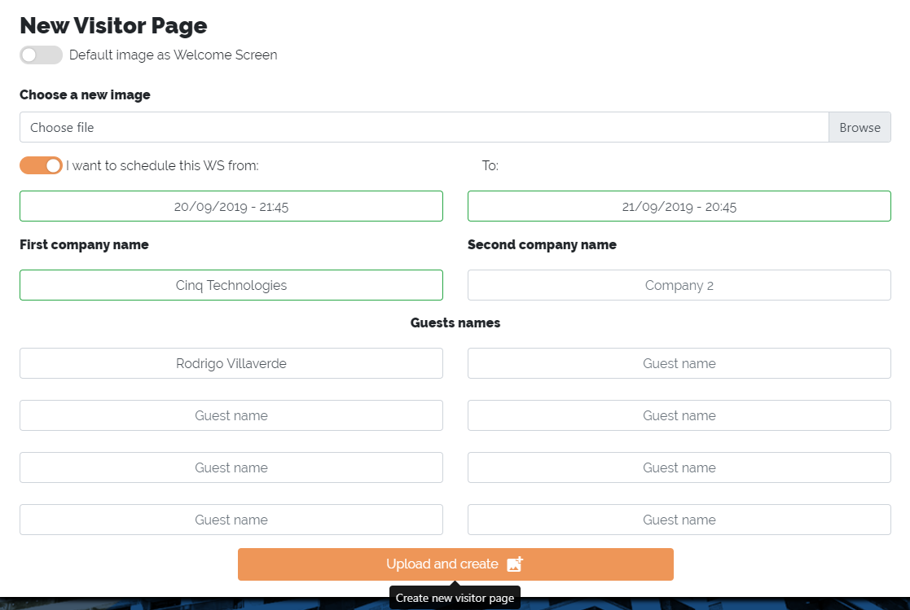

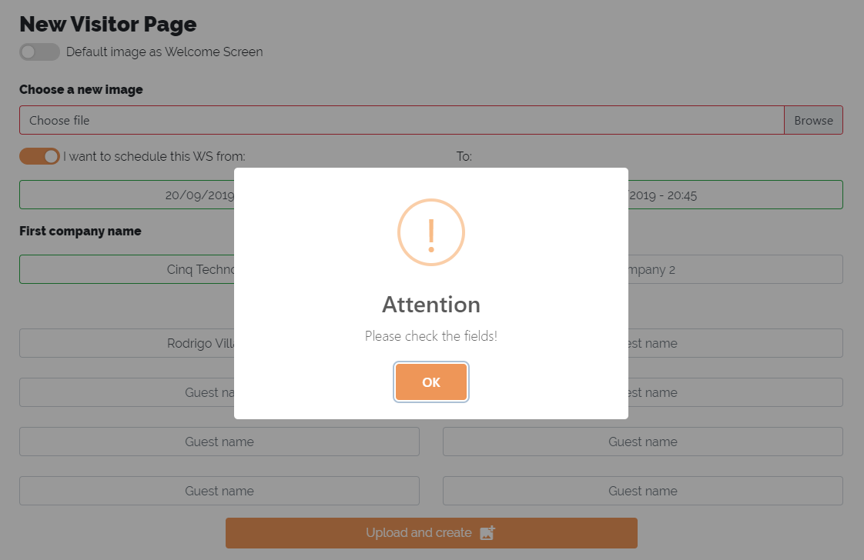

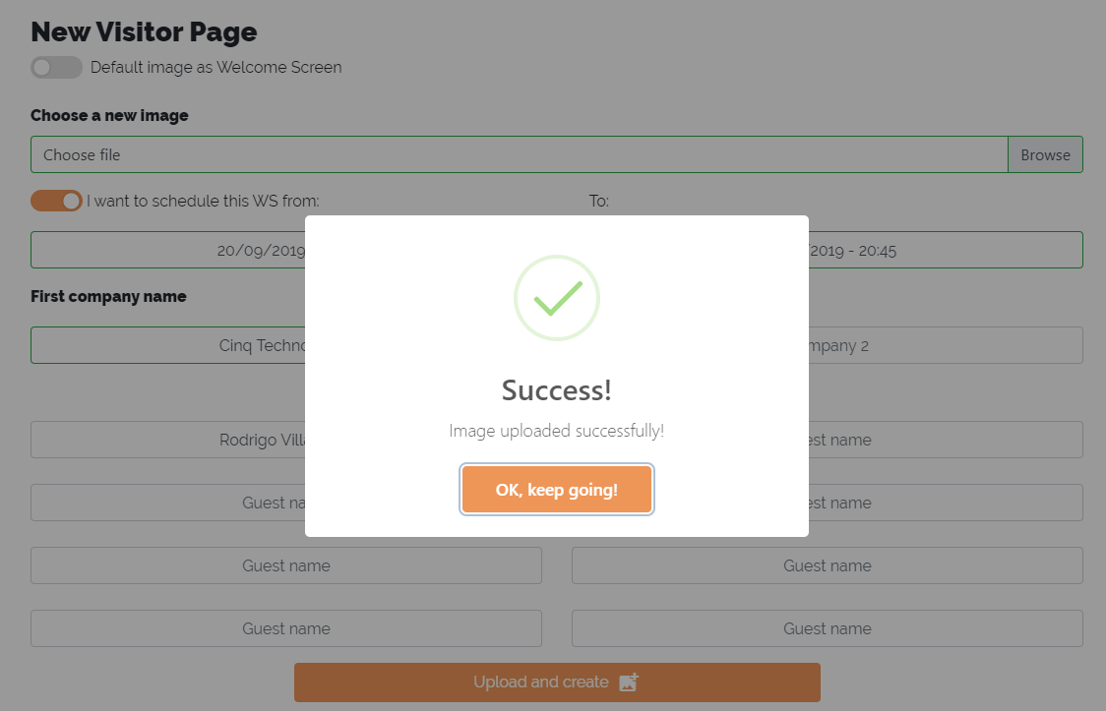

**ATTENTION:**

**- The arrangement of company and guest names on the screen will always be the same on the registration screen.**

- If you weren’t able to register all companies or guests for lack of space, no problem! Add another screen with the required data and all screens displayed in slide form, alternating between them every 15 seconds.

- There is no limit for how many visitor pages are activated at the same time.

- Whenever a new visitor page be activated, if there is any video running, this video will be disabled.

1. Editing a visitor page
   1. To edit a visitor page you can start by clicking on the small pencil of the page you want to edit in the Welcome Screens List.

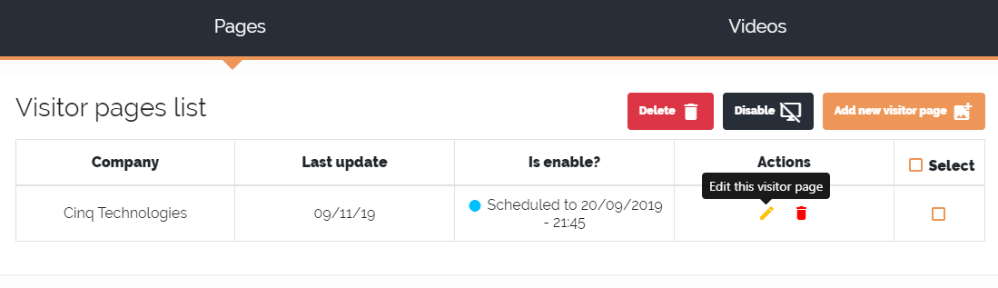

* 1. After that, the screen to editing a visitor page will appear. The rules for editing an existing page are the same as adding a new screen. But there is some differences.

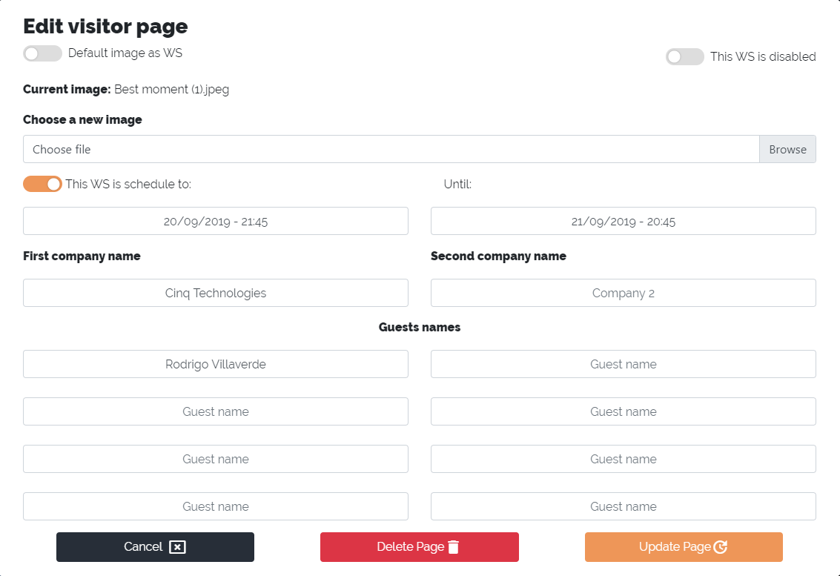

* 1. Note that this page may vary greatly depending on the configuration you registered. However, it is important to note here the *“This WS is disabled”* button. This will be disabled whenever the page is scheduled or disabled. Selecting this will activate the page immediately after editing is complete and your schedule settings will be lost.

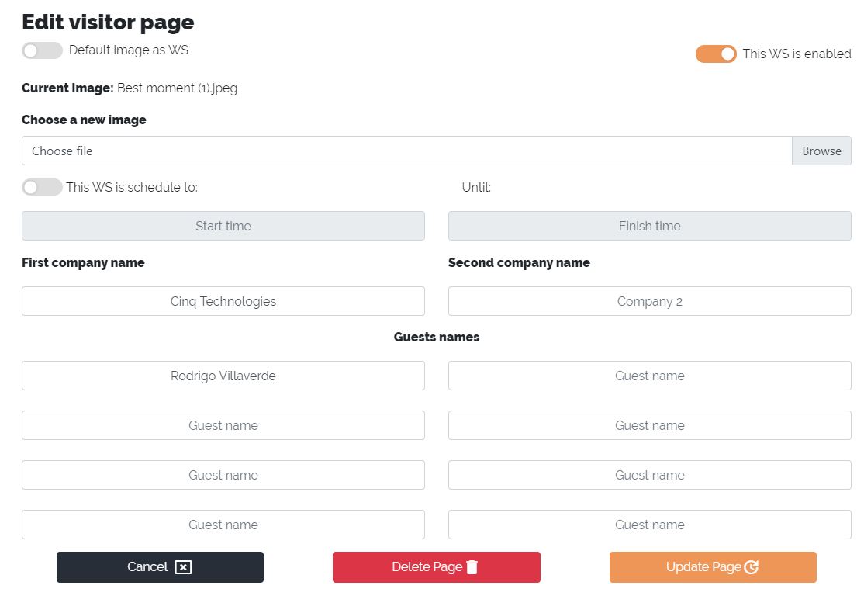

* 1. By clicking the *“Cancel”* button you can undo all modifications made.

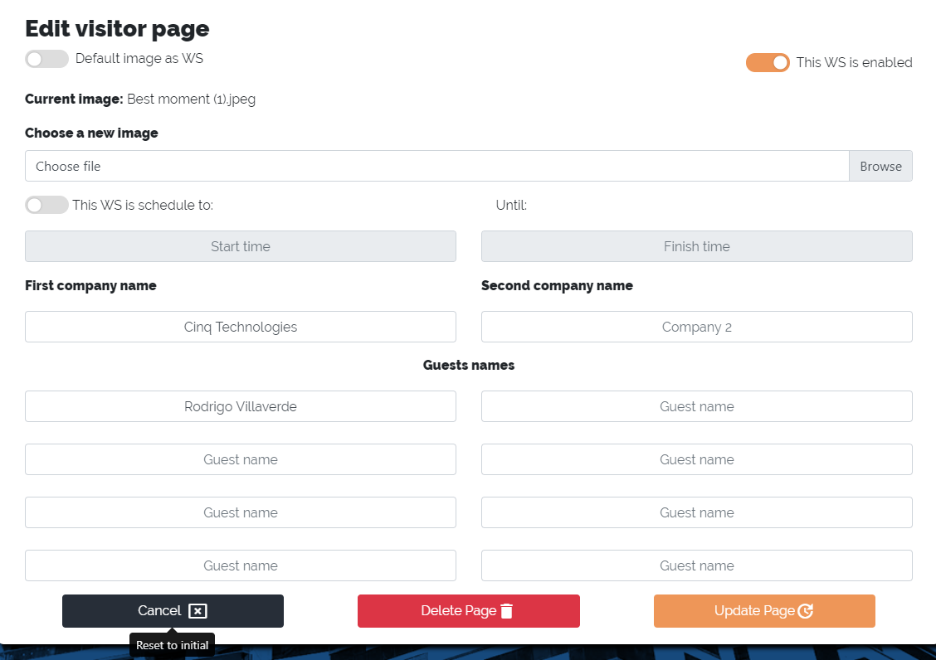

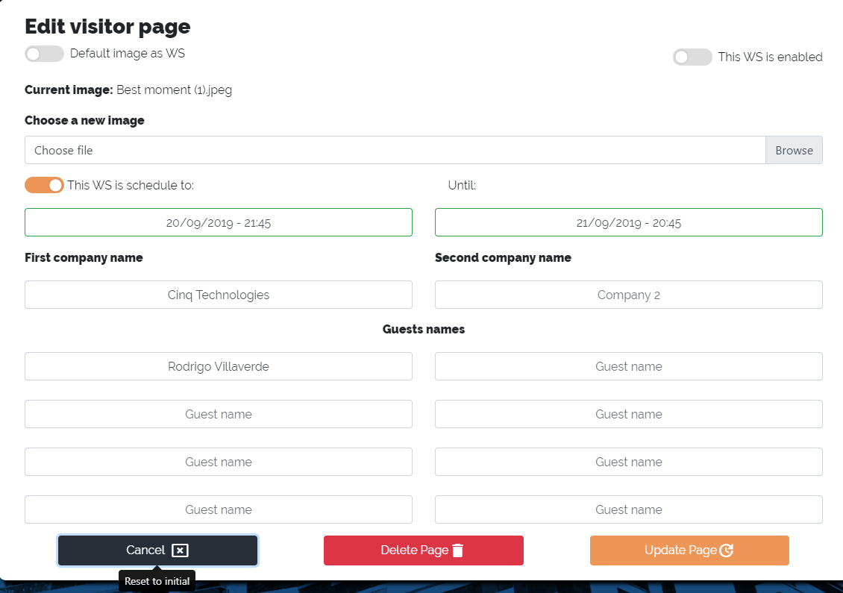

* 1. After completing the modifications just click the *"Update page"* button. If no problem occurs, a success message will appear with the *“OK, keep going!”* button. After clicking it you will be redirected to the Welcome Screen List and your screen will already be updated in the list. 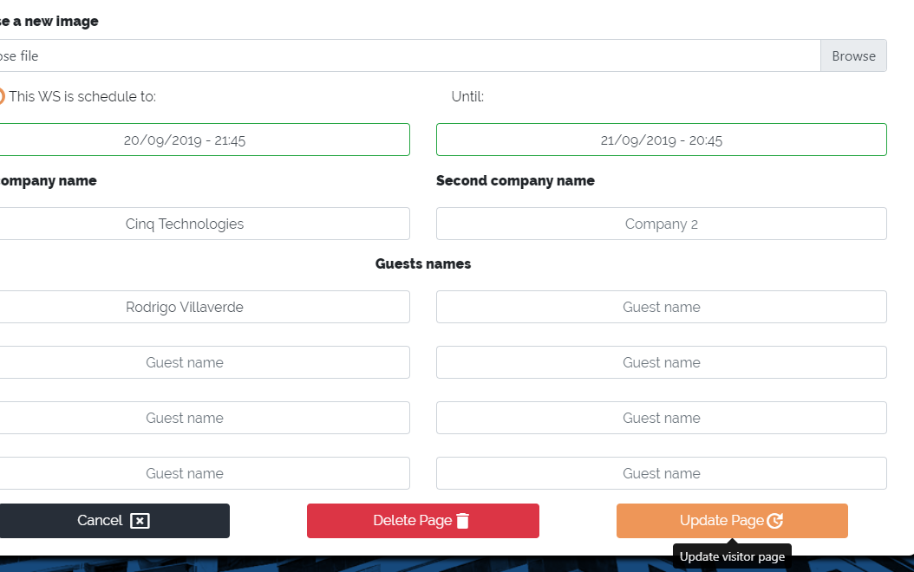

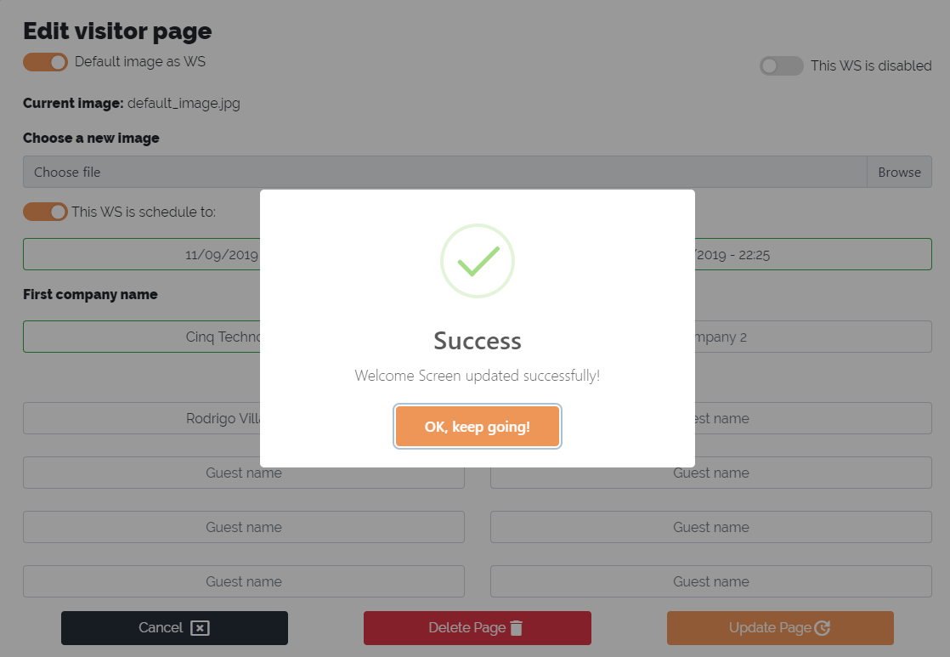

1. Deleting a visitor page
   1. To delete a visitor page you can start by clicking on the small trash can of the page you want to delete from the Welcome Screens List.

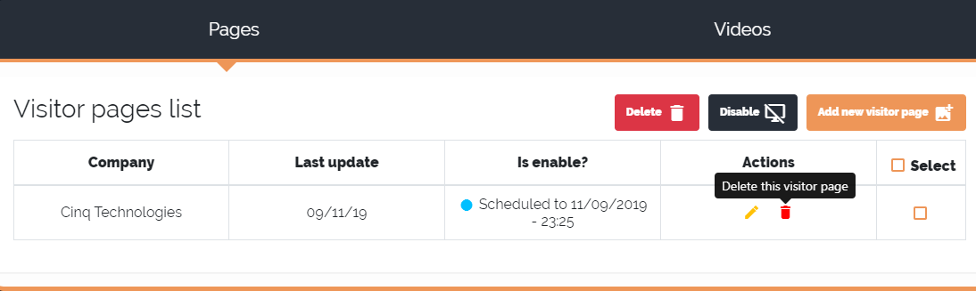

or by clicking on *“Delete page”* within the visitor page edit screen.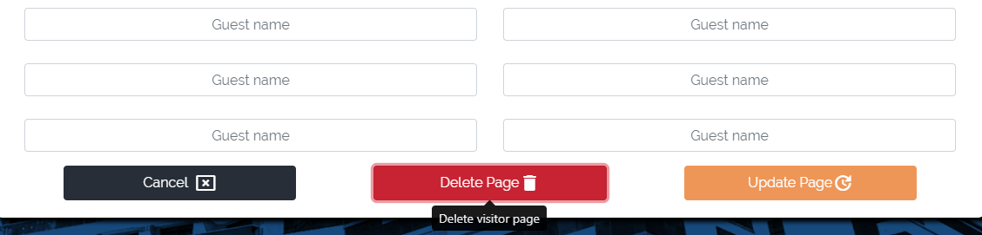

In any case, a message will appear asking if you really want to delete that page. If you do not wish to proceed, click *“No, keep it!”* and a cancel message will be displayed warning you that your page is safe and has not been deleted. Press *"OK"* to proceed.

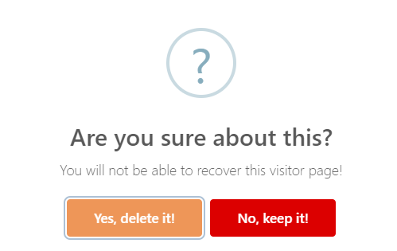

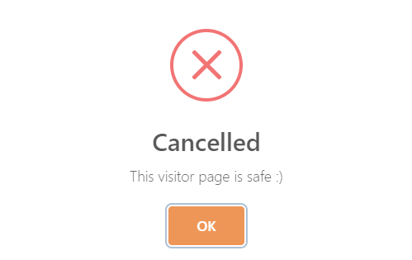

However, if you wish to proceed and delete the page, click *"Yes, delete it!"*. If no problem occurs, a success message will appear with the *“OK, keep going!”* button. After clicking it you will be redirected to the Welcome Screen List and your screen will no longer be in the list.

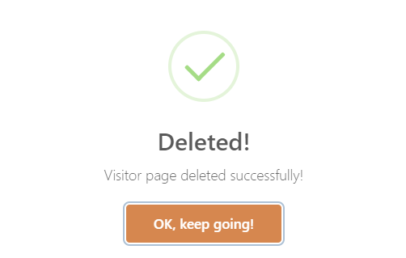

1. Adding a video
   1. To add a new video you can start by clicking directly on *"Add new video"* on the Welcome Screens List

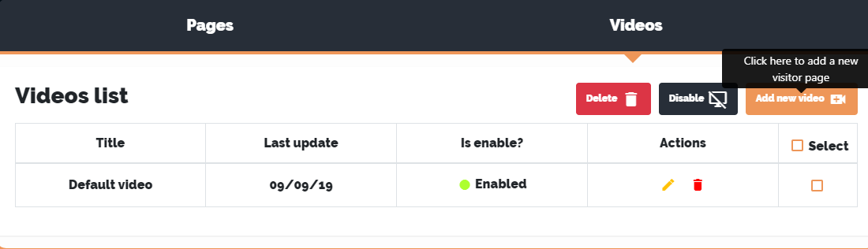

or by clicking on *“Screens”* and then *“New video”* on the navigation bar.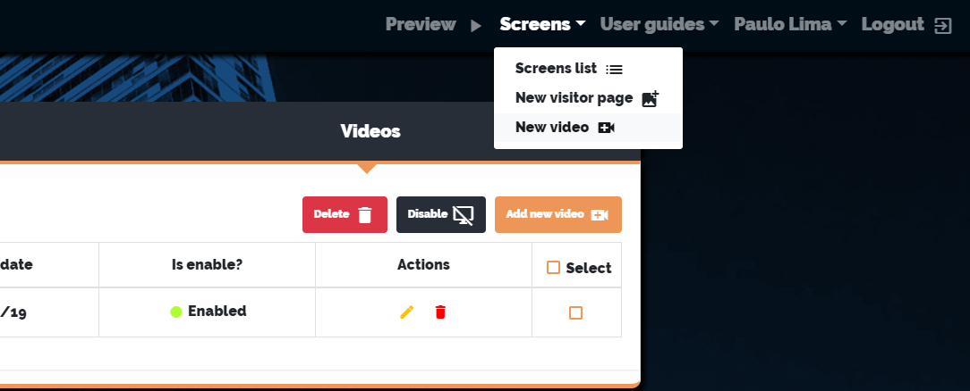

* 1. After that, the screen to add a new video will appear.

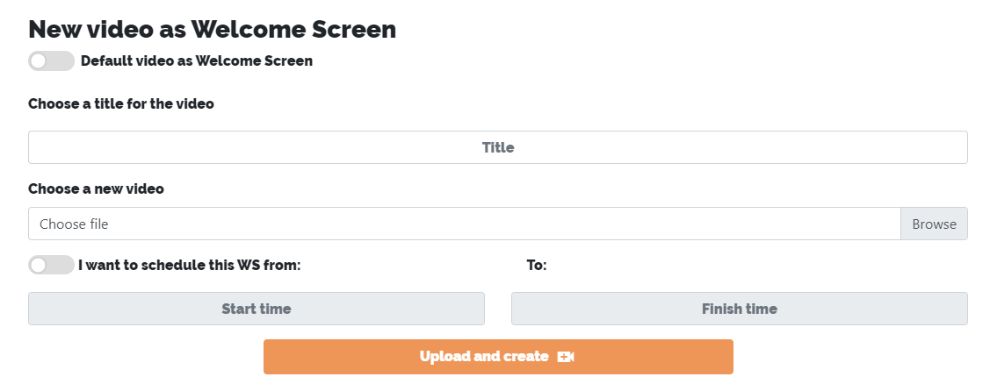

* 1. Note that the*“Default video as Welcome Screen”* option is not selected. This will allow you to upload a new video in the *"Choose a new video"* option to use as the background of your visitor page. However, if you want to use Cinq's default video, select this option and the default video will be automatically selected.

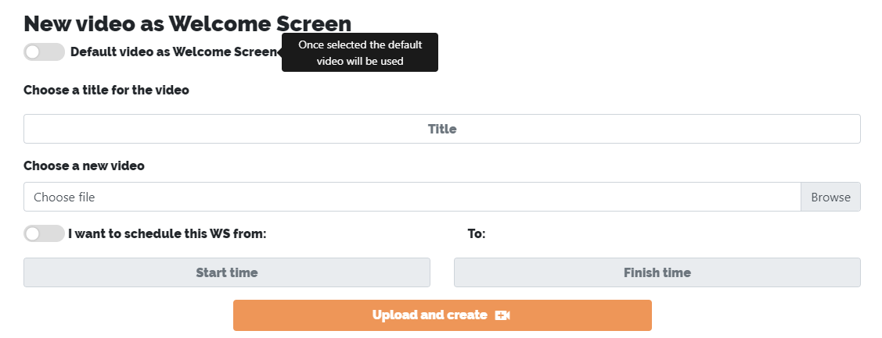

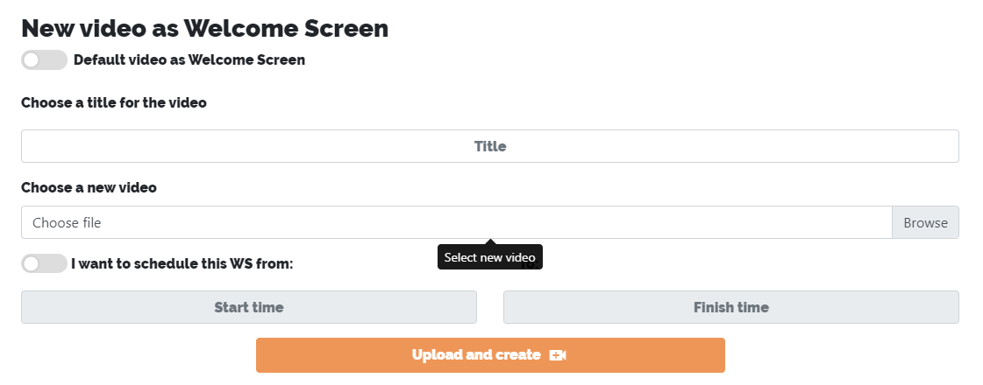

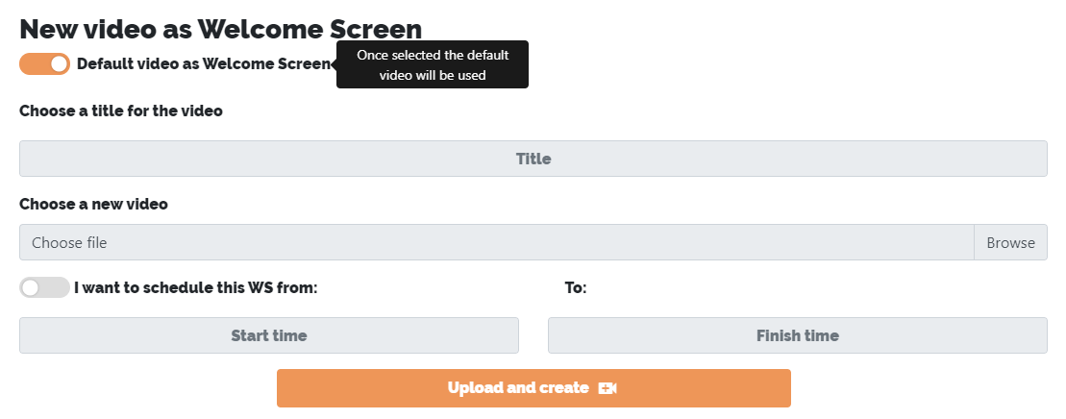

**ATTENTION:**

**- The option to select the default video is only available to system administrator users. If you are not an admin you can only upload new videos.**

* 1. Fill in the *"Choose a title for the video"* field. This field is required. 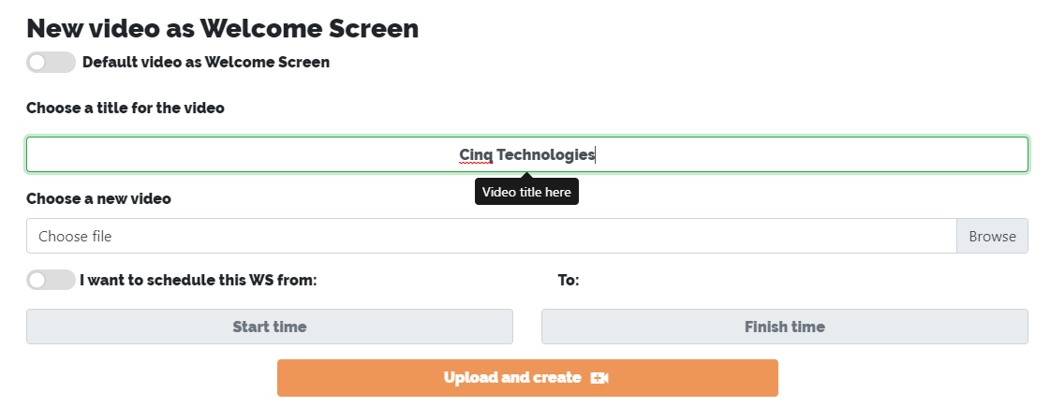
  2. You may notice from previous prints that *“I want to schedule this WS from: ... to:”* is not selected. This means that your new video is not scheduled for any date, which will cause it to activate as soon as you complete the process. However, if you want this video to be enabled on a specific date and time, uncheck this option. This will release the "Start time" and "Finish time" fields and you will be able to choose the video activation and deactivation dates.

**ATTENTION:**

**- The minimum activation time for a video is one hour ahead.**

**- The start date and time of a video must always be greater than the end date, otherwise the fields will turn red and you will not be able to complete the registration.**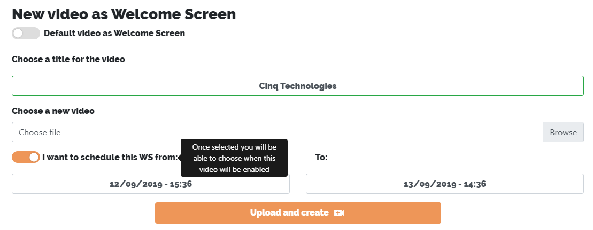

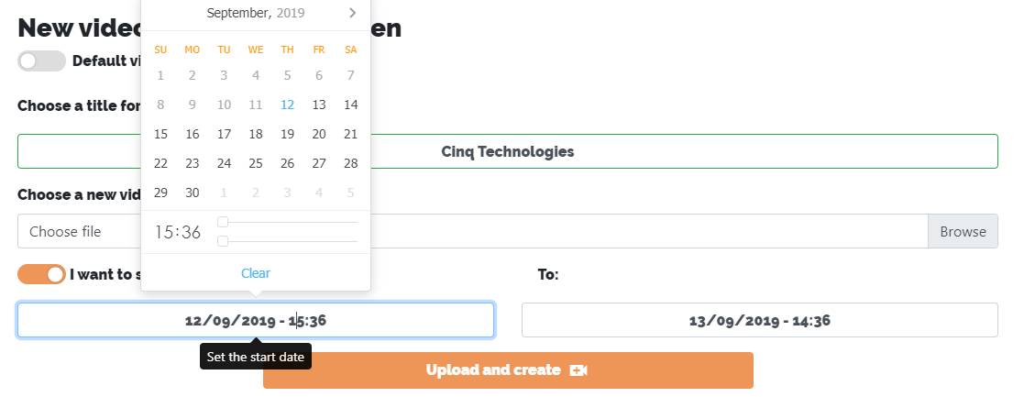

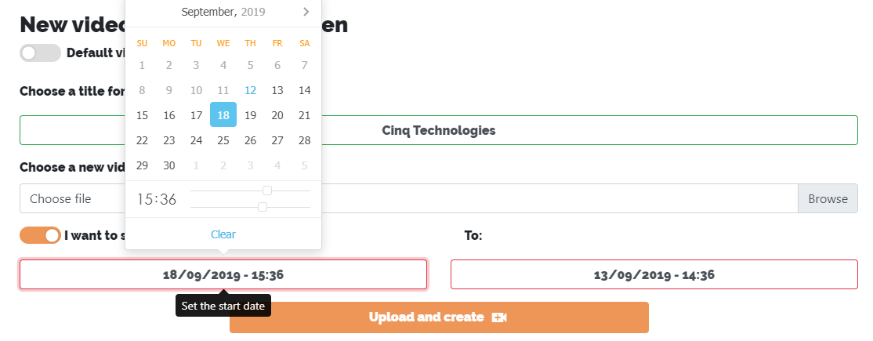

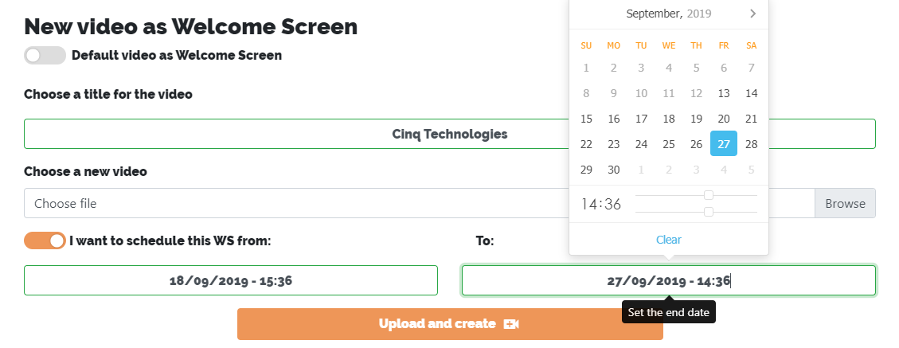

* 1. Now click on *“Upload and create”*. Remember to check if all required fields are filled, otherwise the moment you click the button an error message will appear and you will not be able to proceed. The field that is not right will be marked with red borders. If no problem occurs, a success message will appear with the “OK, keep going!” Button. After clicking it you will be redirected to the Welcome Screen List and your screen will already be registered in the list.

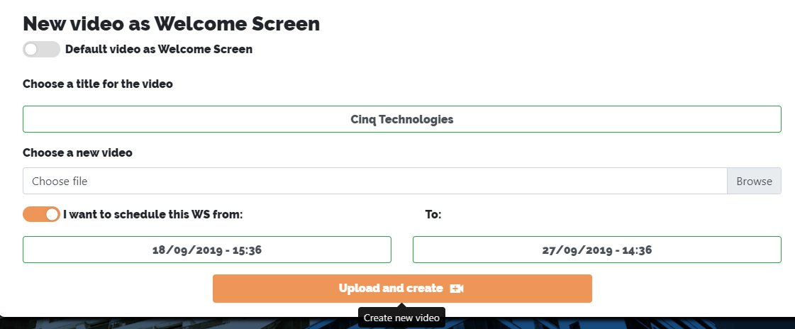

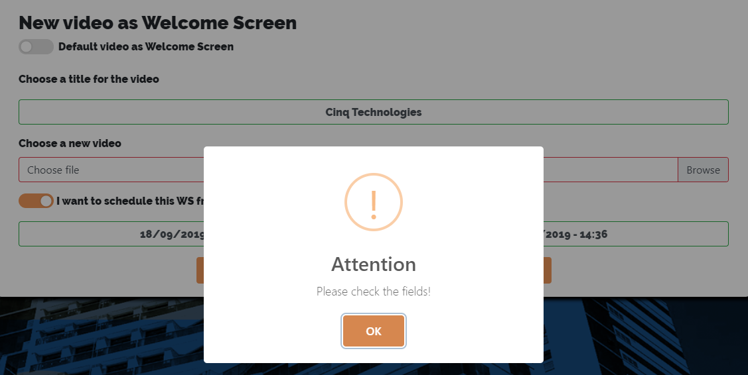

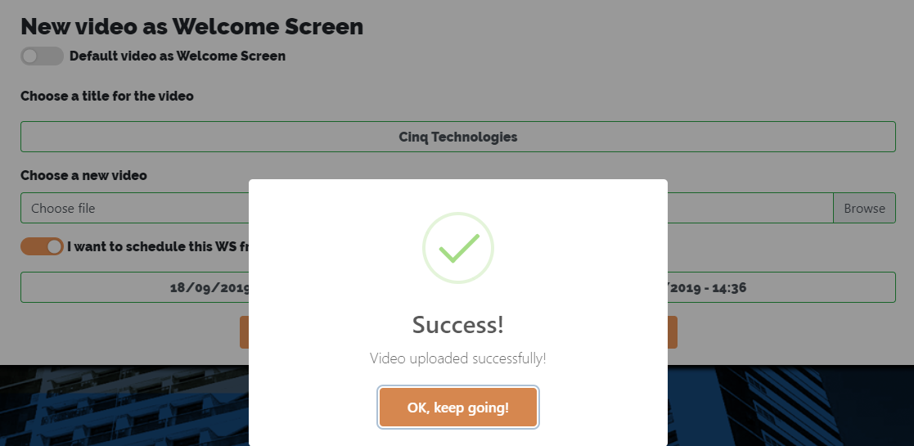

**ATTENTION:**

- Each time a new video is activated, any active content will be automatically disabled.

1. Editing a video
   1. To edit a video you can start by clicking on the small pencil of the video you want to edit in the Welcome Screens List

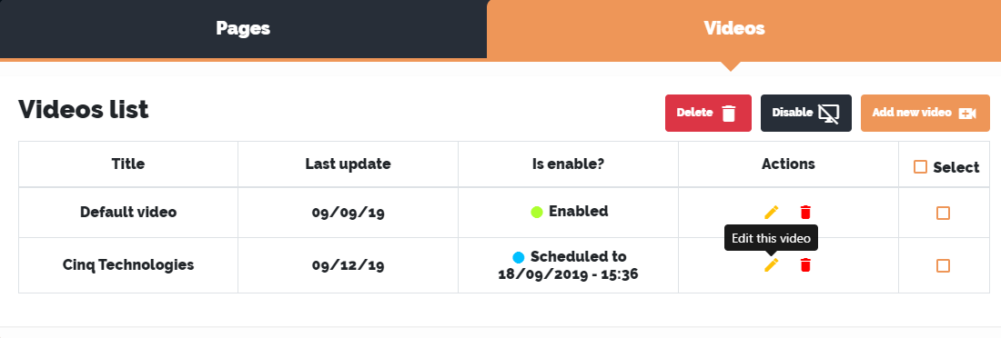

* 1. After that, the screen for editing a video will appear. The rules for editing an existing video are the same as adding a new video. But there is some differences.

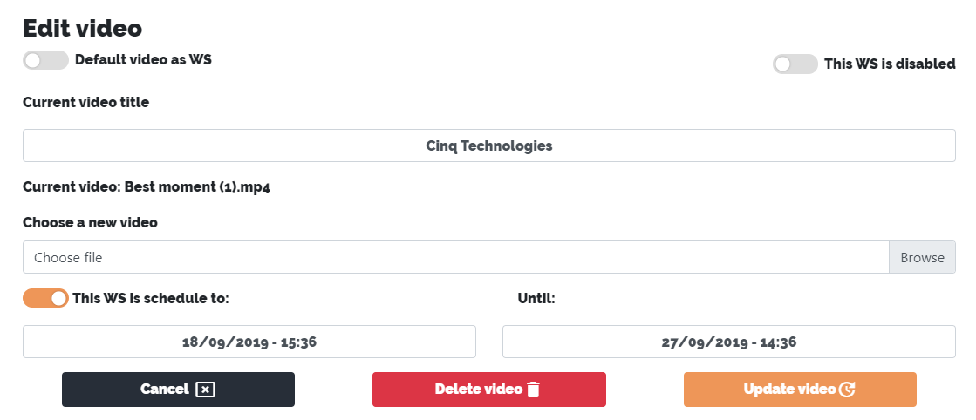

* 1. Note that this page may vary greatly depending on the configuration you registered. However, it is important to note here the *“This WS is disabled”* button. This will be disabled whenever the video is programmed or disabled. Selecting it will activate the video immediately after editing is complete and your schedule settings will be lost.

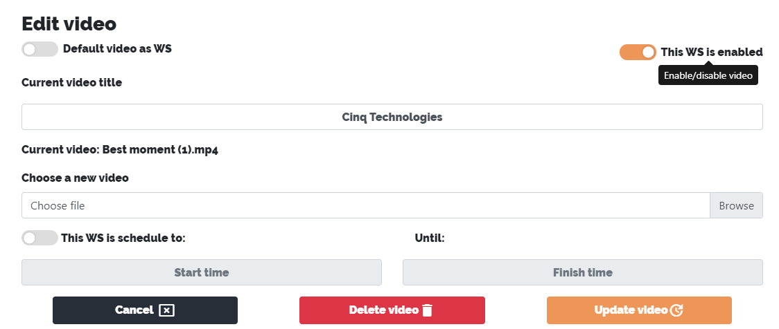

* 1. By clicking the *“Cancel”* button you can undo all modifications made.

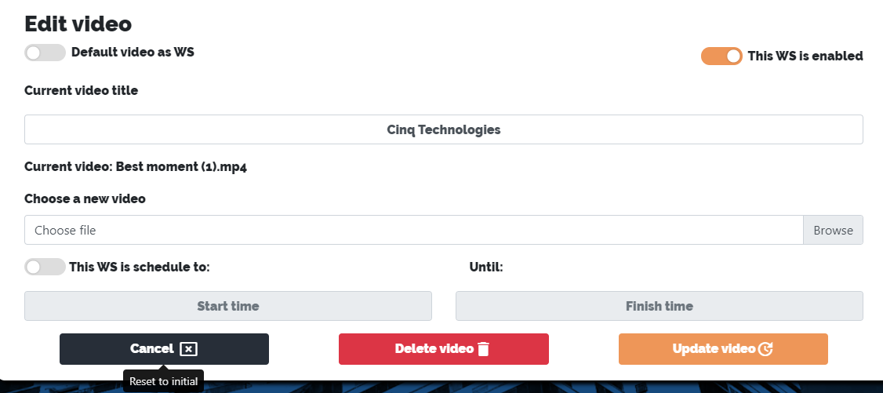

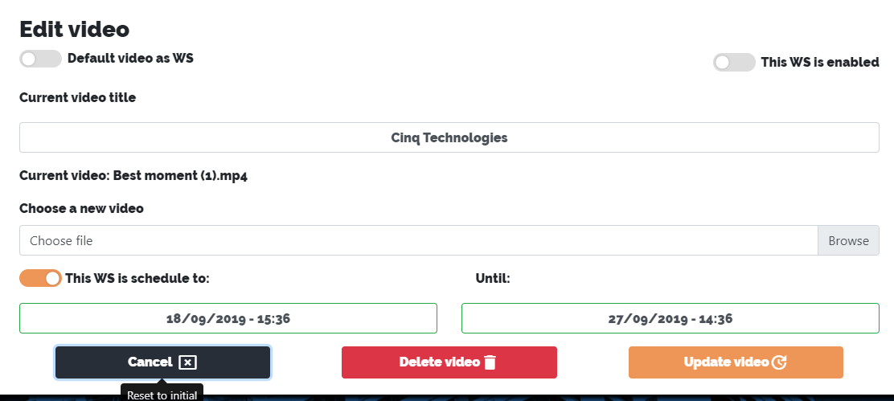

* 1. After completing the modifications just click the *"Update video"* button. If no problem occurs, a success message will appear with the *“OK, keep going!”* button. After clicking it you will be redirected to the Welcome Screen List and your video will already be updated in the list.

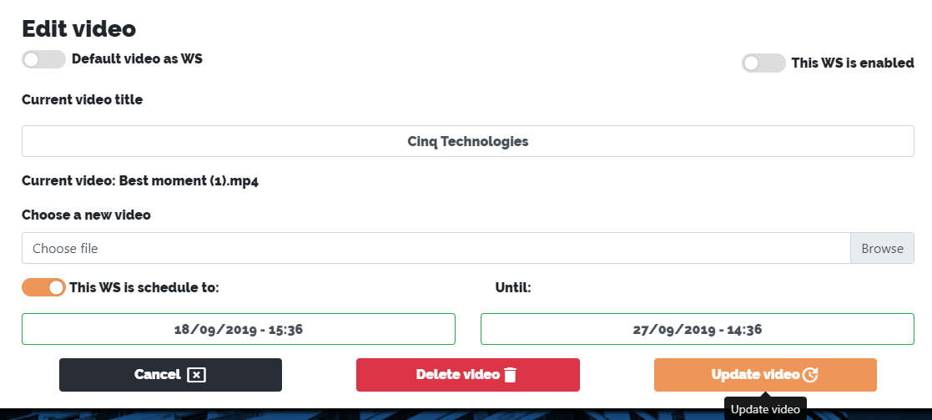

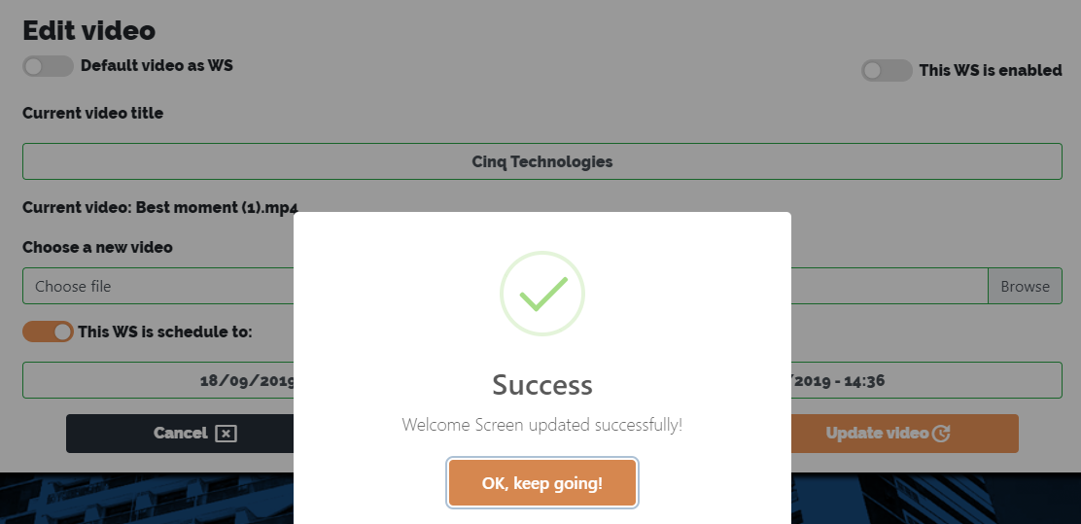

**ATTENTION:**

**- The option to select the default video is only available to system administrator users. If you are not an administrator you can only upload new videos.**

1. Deleting a video
   1. To delete a video you can start by clicking on the small trash can of the video you want to delete in the welcome list.

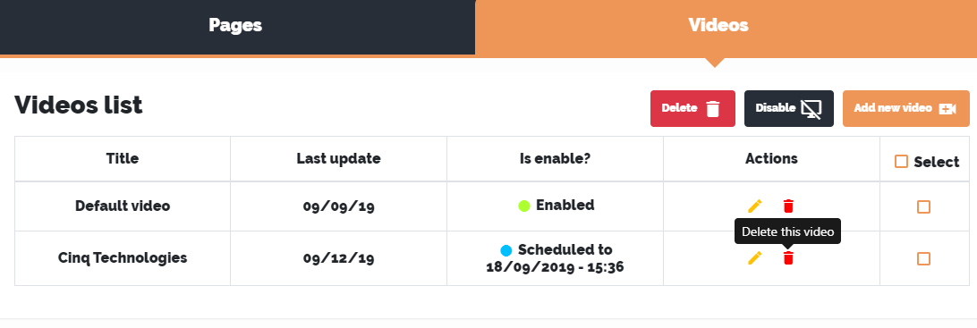

or by clicking on *"Delete video"* within the video editing screen.

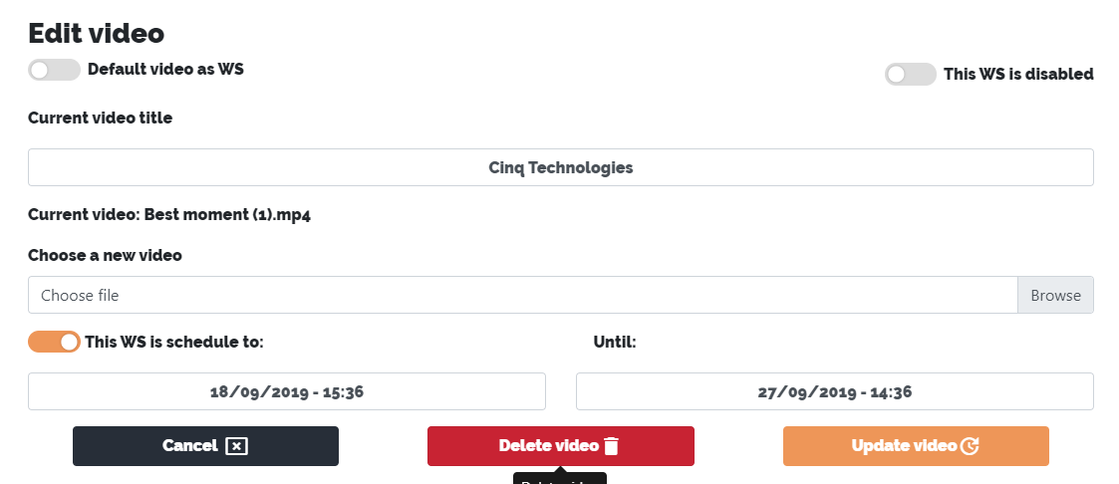

In any case, a message will appear asking if you really want to delete that video. If you do not wish to proceed, click *“No, keep it!”* and a cancellation message will be displayed warning you that your video is safe and has not been deleted. Press *"OK"* to proceed.

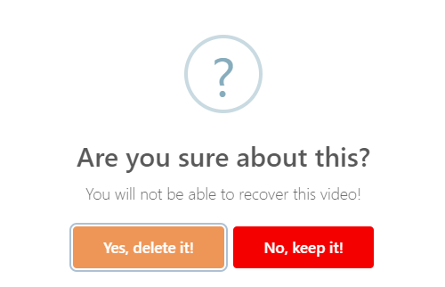

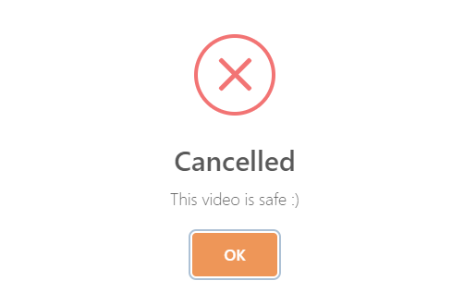

However, if you wish to proceed and delete the video, click *"Yes, delete it!"*. If no problem occurs, a success message will appear with the *“OK, keep going!”* button. After clicking it you will be redirected to the Welcome Screen List and your video will no longer be in the list.

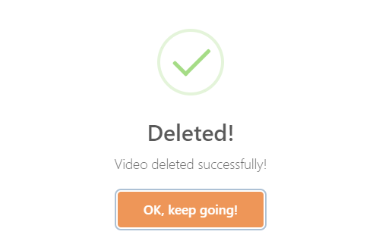

1. Welcome Screens List
   1. Here you have an overview of everything that is registered in the system. You can change the view of only pages to only videos and vice versa.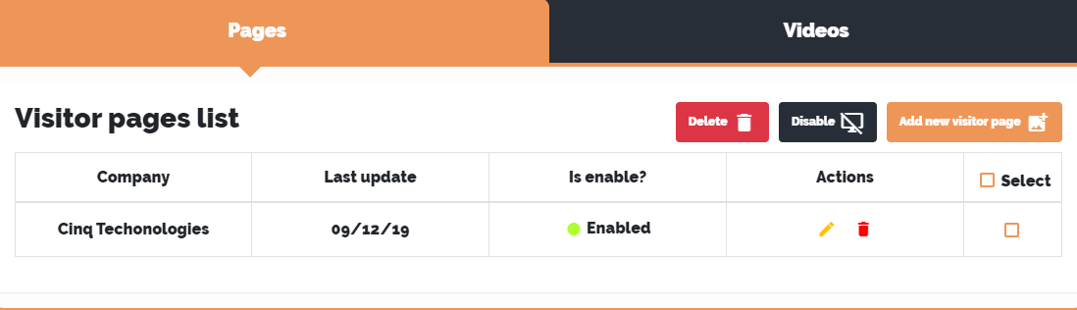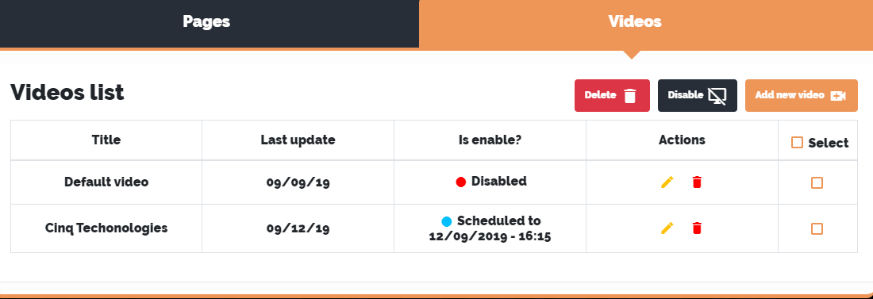

Note that you can see the name of the companies registered in the images and, in the videos, you can see the registered title. In both cases it is also available for viewing the last update date, the status of the W.S. (*Is enable?*), the previously mentioned edit and delete actions (*Actions*) and a checkbox for you to select a particular W.S.

* 1. In the system, a W.S. can have up to three statuses that are characterized by color. They are the following:
* Enable (green) – when W.S. is enabled.
* Disabled (red) – when W.S. is disabled.
* Scheduled (blue) – when W.S. is scheduled for some date. Also shown is the date that W.S. will be activated.

**ATTENTION:**

**- Cinq's default video will only appear to admin users, not being allowed to edit it by users that are not in this group.**

**- Default video will be activated whenever nothing else is enabled.**

1. Deleting/Disabling many W.S.
   1. In the Welcome Screens List you can select multiple W.S. at the same time to delete or disable them together. You can select them all at once by clicking on *“Select”* or just the ones you want. Always remember to have something selected before clicking *“Delete”* or *“Disable”* or an error message will appear.

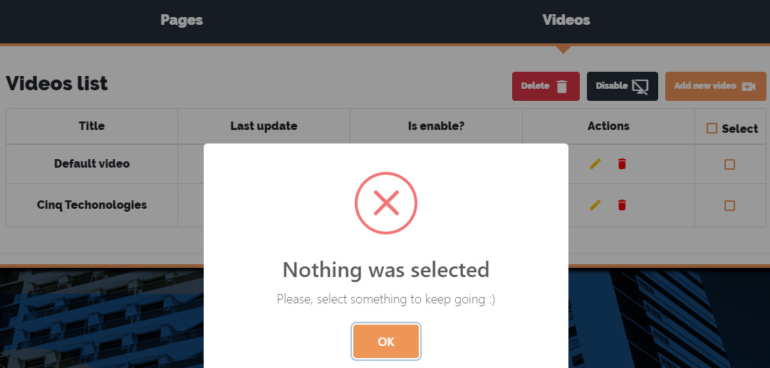

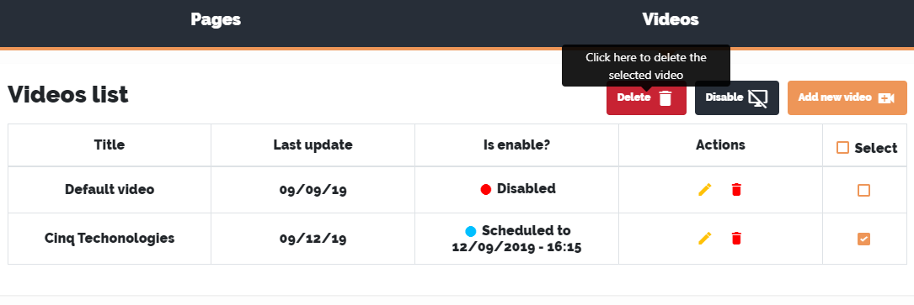 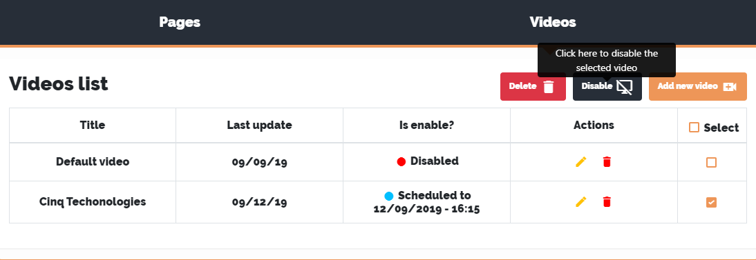

As soon as you click one of the buttons a message will appear asking if you really want to proceed. If you do not want to, click *“No, keep it!”* and a cancellation message will be displayed warning you that your W.S. is safe and has not been deleted or disabled. Press *"OK"* to proceed.

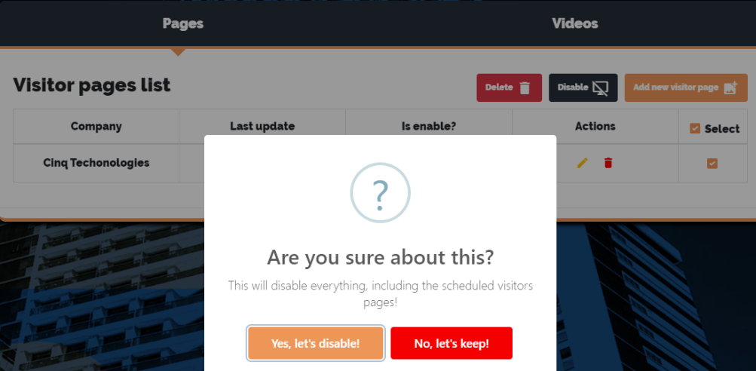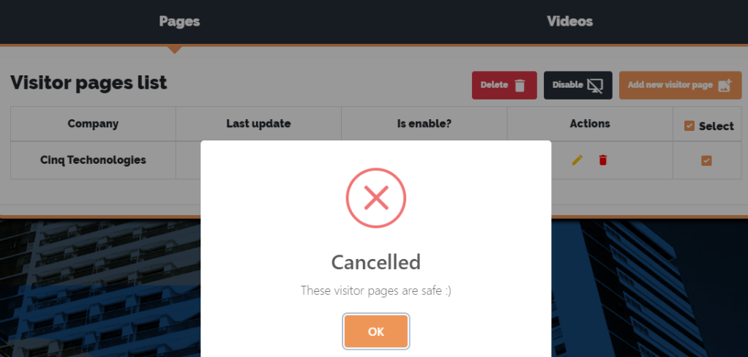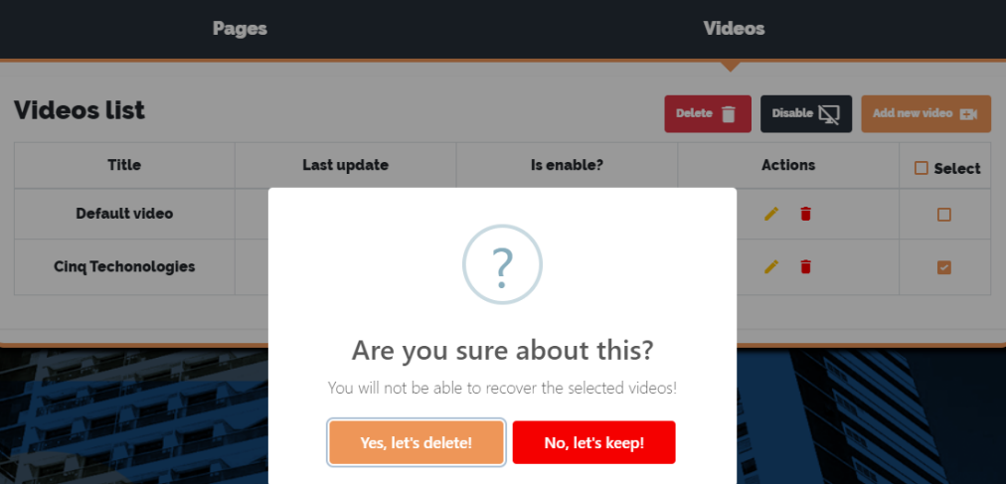

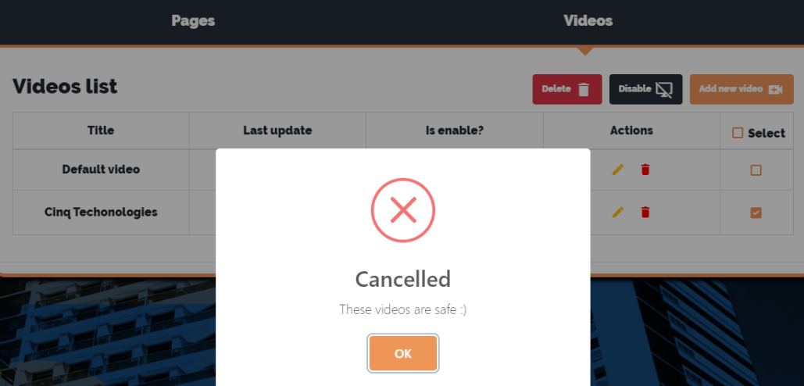

However, if you wish to proceed and delete or deactivate W.S., click *on “Yes, delete it!”* or *“Yes, let’s disable!”*. If no problem occurs, a success message will appear with the *“OK, keep going!”* button. After clicking it you will be redirected to the Welcome Screen List and your updates will be ready.

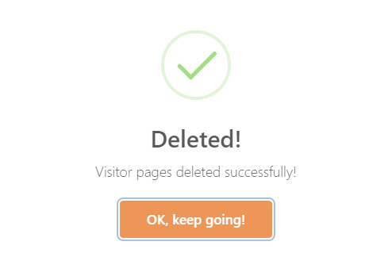 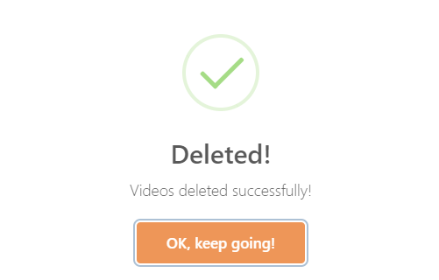

**ATTENTION:**

**- Default video will be activated whenever nothing else is enabled.**

**- If a W.S. If the programmed setting is selected to be disabled it will lose all of its schedule settings.**

1. Welcome Screen Preview
   1. This screen is for occasions when it is not possible to check the final kiosks. Here you can see all the modifications made. This screen can be accessed via the *“Preview”* button in the navigation bar.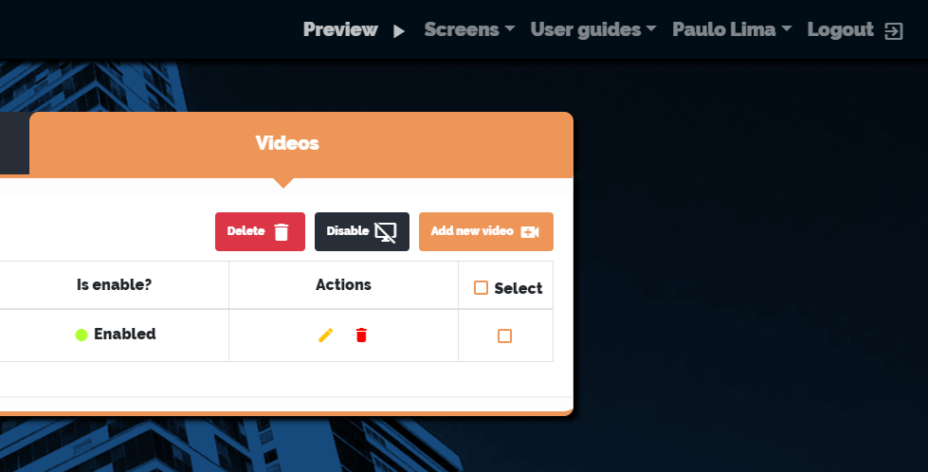
2. Home
   1. This is the page where everything will be displayed to the end user at the kiosk..



1. My account
   1. Here you can check all the details of your account as well as change necessary data. This screen can be accessed via the *“My account”* option in the navigation bar.

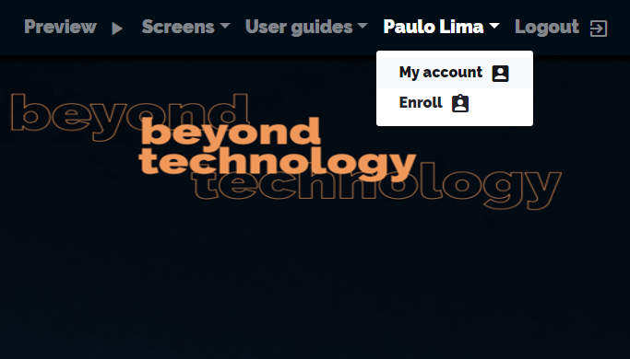

Once all the necessary data has been updated, just click on *“Update my account”.* If no problem occurs, a success message will appear with the *“OK, keep going!”* button. After clicking it you will be redirected to the Welcome Screen List and your updates will be ready.

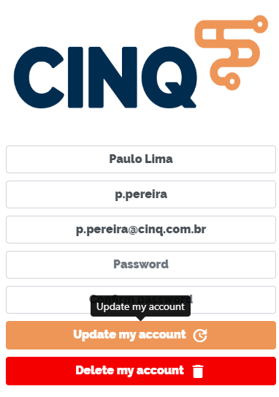

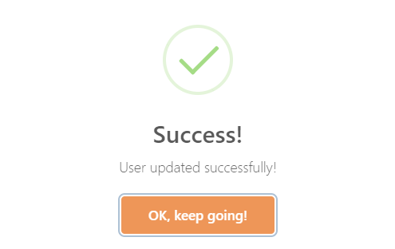

**ATTENTION:**

**- No logins or duplicate emails allowed. If you try to update your data to any of these an error message will appear and you will not be able to proceed.**

**- Each time you change your registration you will need to enter and confirm your password again.**

1. Deleting my account
   1. Once you are on your account screen click on *"Delete my account"*. As soon as you click the button a message will appear asking if you really want to proceed. If you do not want to, click *“No, keep it!”* and a cancellation message will be displayed warning you that your account is secure and has not been deleted. Press *"OK"* to proceed.

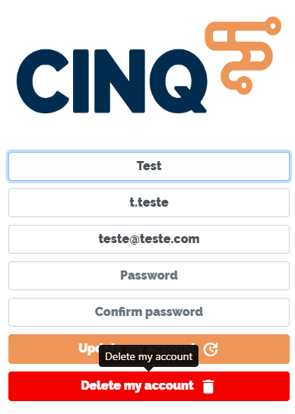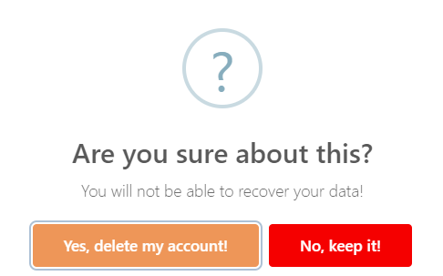

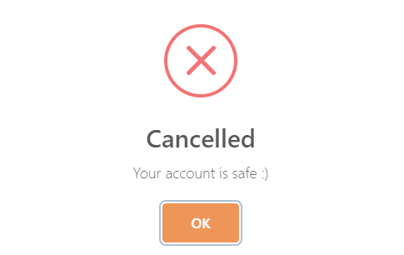

However, if you wish to proceed and delete your account, click *"Yes, delete my account!"*. If no problem occurs, a success message will appear with the *“OK, keep going!”* Button. After clicking it you will be redirected to the main screen (*Home*) and your account will be deleted.

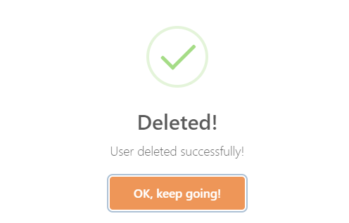

1. Enrolling a new user

**ATTENTION:**

**- - This option is only available to admin users.**

* 1. To access this option simply click *"Enroll"* in the navigation bar, after that the registration screen of a new user will appear..

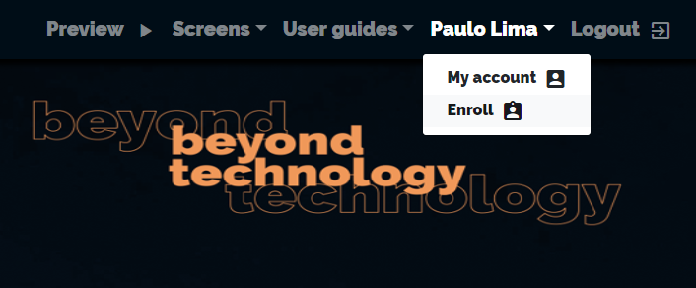

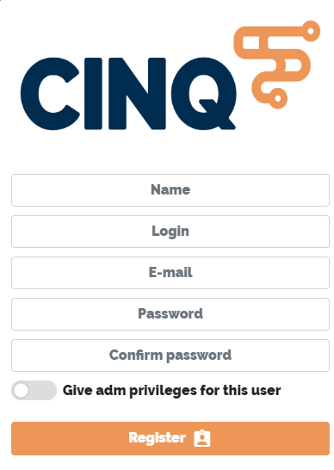

* 1. After that, fill all the necessary data of the new user.

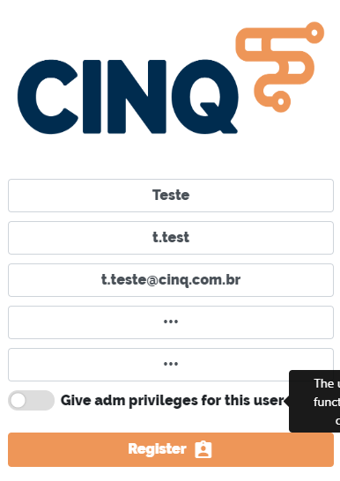

**ATTENTION:**

**- Duplicated login or emails are not allowed. If you try to enter this data an error message will appear and you will not be able to proceed.**

* 1. **You may notice in previous prints that the option *“Give adm privileges for this user”* is not selected. This option allows the user to be an administrator. This type of user has the power to handle Cinq's default video, register new users as well and access to other features. If you want the new user to be an administrator select this option.**

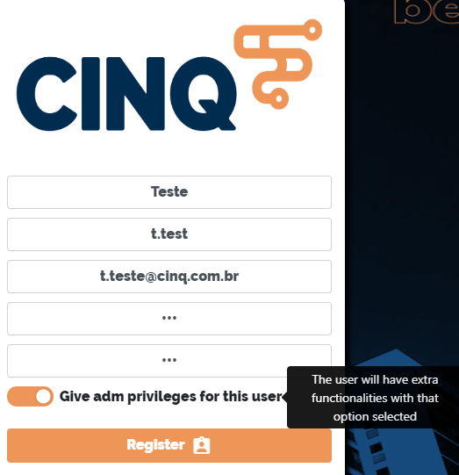

* 1. After completing the completion of the fields just click the *"Register"* button. If no problem occurs, a success message will appear with the *“OK, keep going!”* button. After clicking it you will be redirected to the Welcome Screen List and the new user is already registered.

